Fondue with Fin Briard
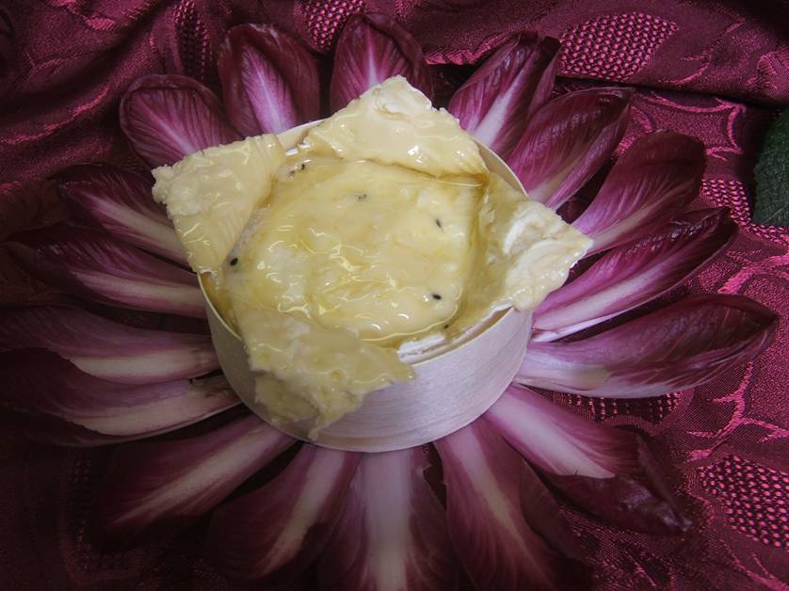

Preparation
Remove the plastic film and cut the crust in a form of a cross
Put back in the wooden box and heat 20 minutes 392°C

Let your imagination flavors your fondue!!
Serving suggestions …

Truffles and walnut bread
Grand Marnier and its salad dressed with sherry citrus fruits vinegar
Pepper and its raw vegetables
Cumin and potatoes “rate” or Noirmoutier
Sesame and sesame bread

Bon Appétit !

